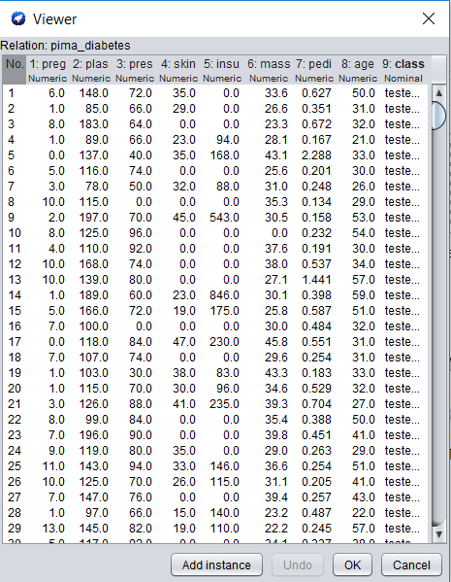

Figure : Diabetes Dataset

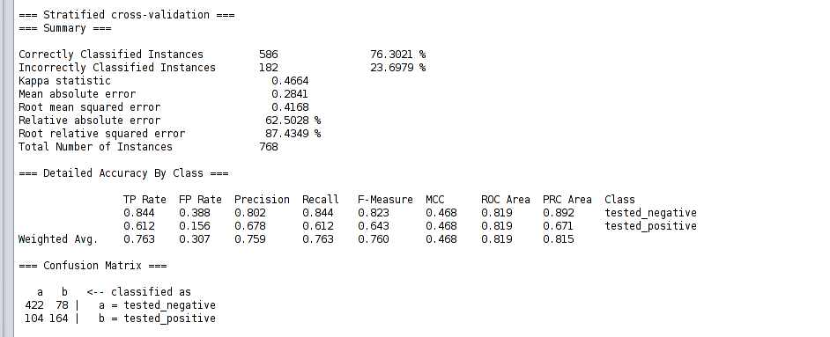

Figure : Naive Baye's Classifier



Figure 1: Diabetes Dataset

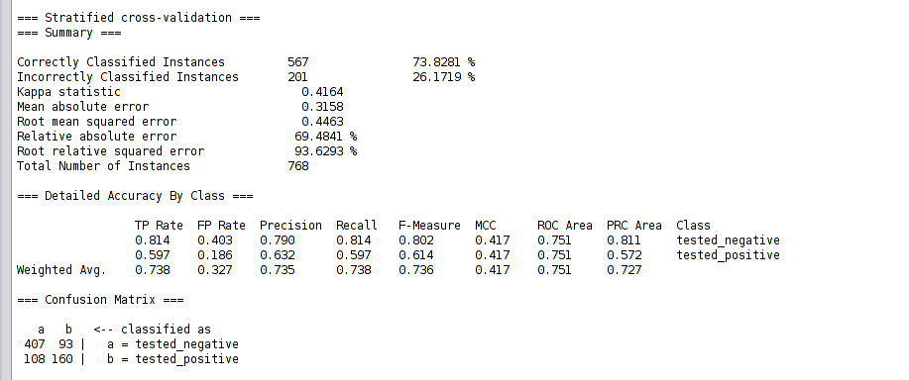

Figure 2: J48 Classifier



Figure 1: Diabetes Dataset

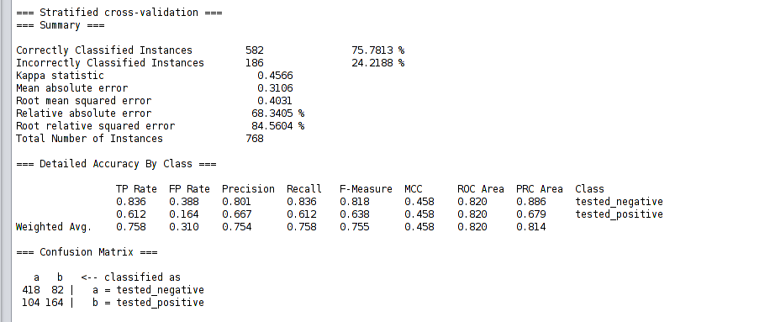

Figure 2: Random Forest Classifier



Figure1: Diabetes Dataset

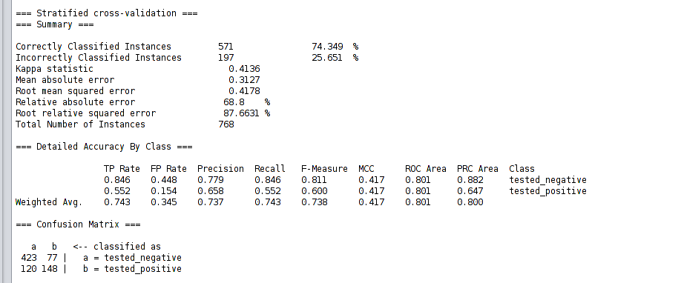

Figure 2: Adaboost Classifier



Figure 1:Diabetes Dataset

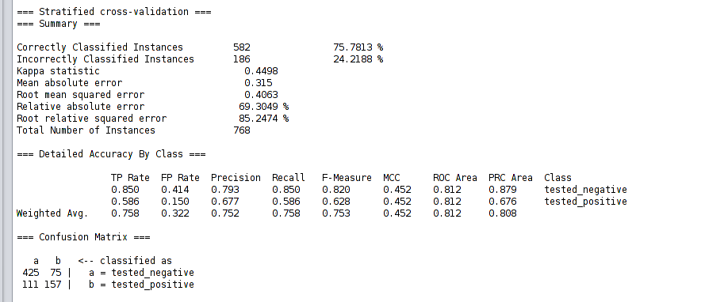

Figure 2: Bagging